Order Of Service

Singing: Psalm 116—CW page 107

Reading: Psalm 90

Opening Hymn: TLH 227

Reading: Acts 16:35-40

Request Hymn: CW Supplement 702

Reading: Matthew 6:1-4

Sermon Hymn: TLH 236

Sermon Text: Mark 3:27-30

The Unforgivable Sin

Prayer

The Apostles’ Creed, TLH page 12

Holy Communion

The Lord's Prayer

The Blessing

Closing Hymn: TLH 46

* * * * * * * * * * *

Bible Study: Lambs: Leaf
Sheep: Proverbs 16:6-10
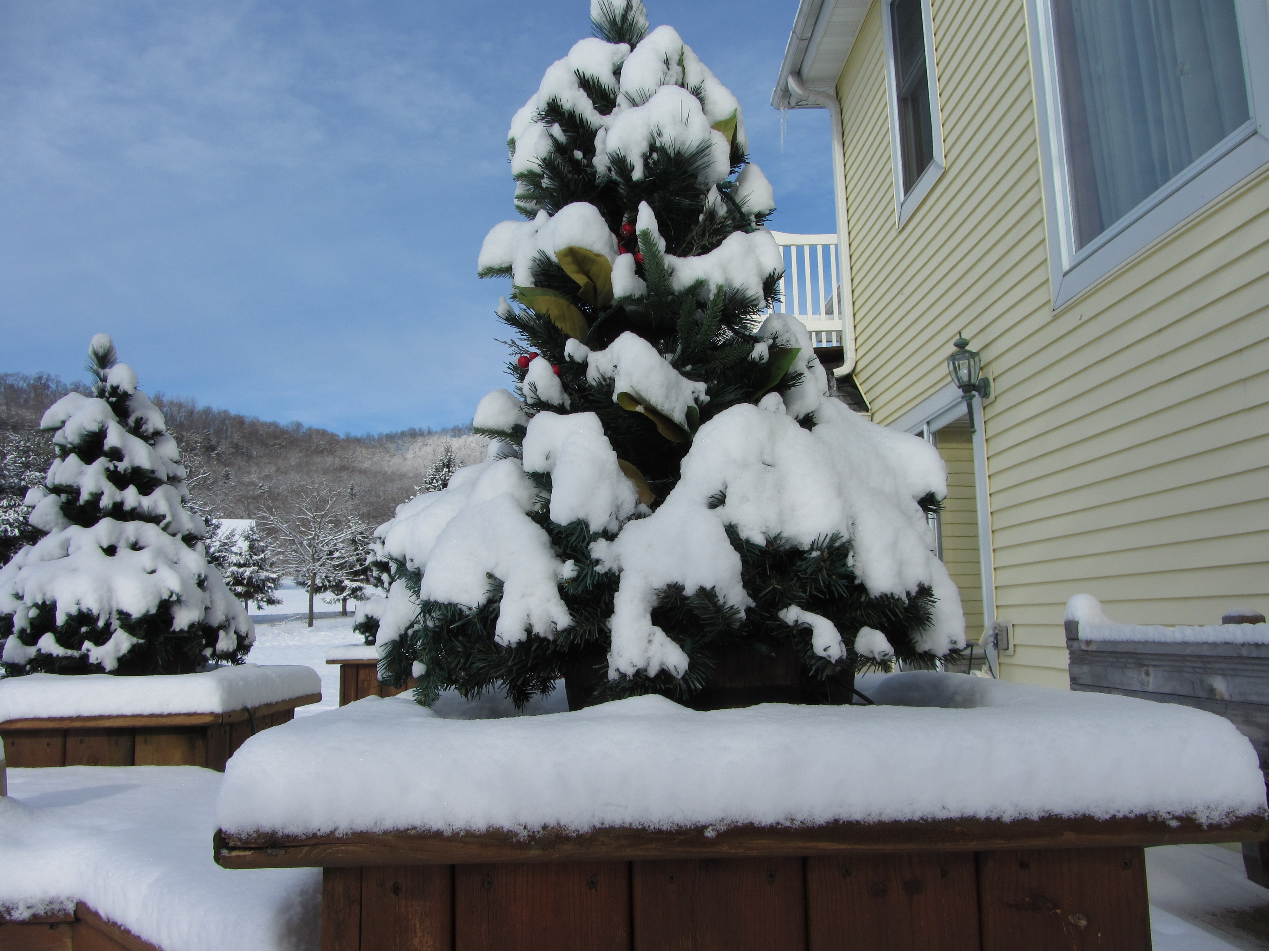

Winter At MGMF

Water
Of
Life

27 January 2019

W A T E R O F L I F E

Independent Christian Church—Conservative Lutheran Doctrine

Worship Service: 9:30 a.m. Bible Study: 10:45 a.m.

Larry Cooper, Pastor E-Mail address:
111 N. Ridge Road lcooper@wateroflife.cc
Coon Valley, WI 54623 Web Site:
www.wateroflife.cc

* * * * * * * * * * * * * * * * * * * * * * * * * * *

Sermon Text: Mark 3:27-30

The Unforgivable Sin

* * * * * * * * * * * * * * * * * * * * * * * * * * *

ark 3:27 No man can enter into a strong man's house, and spoil his goods, except he will first bind the strong man; and then he will spoil his house.
:28 Verily I say unto you, All sins shall be forgiven unto the sons of men, and blasphemies wherewith soever they shall blaspheme:
:29 But he that shall blaspheme against the Holy Ghost hath never forgiveness, but is in danger of eternal damnation:
3:30 Because they said, He hath an unclean spirit.



Hebrews 6:4 For it is impossible for those who were once enlightened, and have tasted of the heavenly gift, and were made partakers of the Holy Ghost, :5 And have tasted the good word of God, and the powers of the world to come, :6 If they shall fall away, to renew them again unto repentance; seeing they crucify to themselves the Son of God afresh, and put him to an open shame.

Hebrews 10:26 For if we sin wilfully after that we have received the knowledge of the truth, there remaineth no more sacrifice for sins, :27 But a certain fearful looking for of judgment and fiery indignation, which shall devour the adversaries. :28 He that despised Moses' law died without mercy under two or three witnesses: :29 Of how much sorer punishment, suppose ye, shall he be thought worthy, who hath trodden under foot the Son of God, and hath counted the blood of the covenant, wherewith he was sanctified, an unholy thing, and hath done despite unto the Spirit of grace? :30 For we know him that hath said, Vengeance belongeth unto me, I will recompense, saith the Lord. And again, The Lord shall judge his people. :31 It is a fearful thing to fall into the hands of the living God.

